

PRE – INSTALLATION CHECK GUIDE ONLY
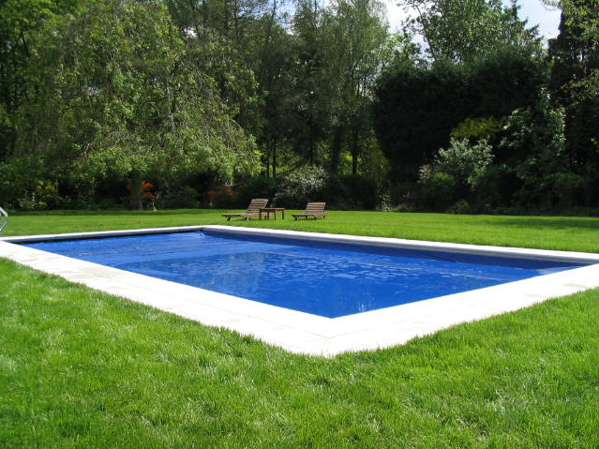

Coverstar Pre-Installation Guide

Preparing a Concrete Pit / Pit Construction

- The pit must be built to the correct dimensions as follows.
  - Covers up to 40’ require an internal pit size of 14” x 14”
  - Covers up to 50’ require an internal pit size of 15” x 15”
  - Covers up to 60’ require an internal pit size of 16” x 16”
- The pit walls must be finished square and level with the pool walls.
- The pit must protrude 30” (762mm) past the inside of track (for drive end) and 10” (254mm) past inside track for the non-drive end.
- The pit must be constructed in concrete blocks (standard 18” (457.2mm) x 9” (228.6m) x 4” (101.6mm) to create solid walls and the base must be a minimum of 3” (76.2mm) thick.
- The walls and base must be rendered to create a flat and smooth finish.
- The dividing wall between the pit and pool must have at least 1” (25.4mm) radius edges at the top – no sharp corners must be left, as cover could catch.
- A drain to a soak-away must be installed, ideally in the centre of the pit floor and rendered so that there is a gradual fall to a low point in the centre of the floor. It is advisable to install a fitting such as a petal inlet, to prevent leaves and debris clogging the drain.
- A non-rigid conduit of at least 3” (76.2mm) must be installed from the mechanism (drive) end of the roller to the power pack in the plant room. The conduit must exit the pit from the bottom of the end wall at the mechanism end, or from the side wall as close to the end wall as possible and at the bottom of the pit. If bends can not be avoided in the run, please ensure they are swept bends as opposed to 90 degree.
- To enable the installation team to pull the hydraulic hose through, a draw cord should be installed at the same time as the 3” (76.2mm) conduit.
- Please ensure that no pipe work or electrical cables pass with 19” (0.5m) of the side or underneath the Coverstar pit as these could be damaged as a result of the mechanism fixings.
- There must be at least 3’ (914.4mm) of walk way around the perimeter of the pool, to ensure the engineer has access for installation. If this is not available, please contact Certikin.

Preparing the Pool for a Deck Mount Coverstar

- Check pool surround for obstacles such as skimmer lids or under water light deck boxes, as this will determine where the roller and track are positioned.
- Decide where the roller is going to be placed at the end of the pool and where the trolleys will stop. Check for deck boxes and walk ways etc. Explain the implication of drag, if the roller is situated quite a way back from the pool.
- There must be sufficient room to allow for 30” (762mm) past the inside of track (for mech end) and 10” (254mm) past inside track for the non-mech end.
- A non-rigid conduit of at least 3” (76.2mm) must be installed from the mechanism end of the roller to the power pack in the plantroom. The hose must exit at far corner of the mechanism end or at the side, at the bottom of the pit. If bends can not be avoided in the run, please ensure they are swept bends as opposed to 90 degree.
- The pool surround should be firm, level and strong enough to accept the fixings and strain exerted by the Coverstar system. Any loose slabs must be re-laid.



Before your Coverstar is delivered please ensure that you are able to tick yes to all of the following questions.

PLEASE CHECK | YES | NO | N/A | COMMENTS
Is the pool construction finished?
Is the water to its final fill level?
Is the surrounding decking/paving level and solid – will it offer a secure fixing base? There must be at least a 3” concrete base to fix to.
If encapsulated under guide, have the encapsulation and guide been built into the pool wall?
If flush guide, have the channels been set/dug at the correct depth and parallel spacing?
Is the bed under the channel and the base of the pit solid?
Recessed pit: has the pit been built to the correct size: - pool length up to 40ft pit: 14 inches²; 40 to 50ft: - 15inches²; over 50ft: - 16 inches²
Is the pit clean and the walls & base smooth?
Has a drainage point been fitted into the pit?
Have conduit and draw cord been installed for the hydraulic hoses?
Is the ordered hydraulic hose length still correct? (Check original order form)
Is there suitable space/positioning for the hydraulic pump/motor?
Is there a power supply to the hydraulic pump/motor?
Will a separate power supply be available for use?
When the key switch is positioned, will the full operation of the cover be visible?
Can a member of your staff be made available on the installation date?
Electrical requirements: 20 amp C rated breaker in the plant room for the hydraulic motor, in conjunction with current wiring regulations. Key Switch requires a 3-core; 1.5mm cable
Is there a socket for the cover pump, within 8 metres of the pool?
Is there a mains outlet to plug in power tools?
Panel pools only: Does the dividing wall panel have brickwork (3” minimum) behind to act as an anchor for the mechanism mounting?
Any additional comments:

